# Software User’s Manual

## Installation Guide

### Setting up environment at server side

The following software must be installed into the server machine:

* Microsoft Windows 7 or a higher version
* Apache Tom Cat version 6 (can download from <http://tomcat.apache.org/>)
* Java Runtime Environment version 6 (can download from <http://www.microsoft.com/en-us/download/details.aspx?id=21>)
* mysql-5.1.65-win32 or higher (can download at <http://www.mysql.com/downloads/> )

### Deployment at server sites

* Open MySQL and import bus-reservation.sql to create a new schema named bus_reservation.
* Copy file bus-reservation.war to [Tomcat folder]\webapps.
* Copy file .keystore to a preferred folder.
* Open [Tomcat folder]\conf\server.xml, add the following line if not exists. Replace the value of keystorefile with the path to the file .keystore.

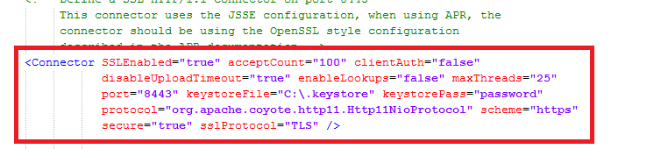

* Start Tomcat server by running [Tomcat folder]\bin\startup.bat
* After the server successfully start up, modify the following files:
  + [Tomcat folder]\webapps\bus-reservation\WEB-INF\classes\database.properties and change the following rows:

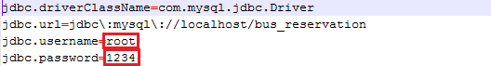

Change the value of jdbc.username to MySQL login username

Change the value of jdbc.password to MySQL login password

* Shutdown Tomcat server by running [Tomcat folder]\bin\shutdown.bat. Start the server again.

### Setting up environment at client side

The client devices need to have one of the following browsers to access the bus-reservation websites:

* Google Chrome version 20 or higher(can download at <https://www.google.com/intl/en/chrome/browser/>)